Project Report on

Automated Web Application Deployment
Security Analysis and Monitoring.


Submitted in partial fulfillment for the award of
Diploma in PG-DITISS

from Sunbeam Institute of Information Technology (Pune)

Guided by:
Prof. Sandeep Walvekar

Presented By:

Mr. Aryan Bamane | PRN: 250844223005
Mr. Chirayu Humar | PRN: 250844223009
Mr. Somya Jain | PRN: 250844223047
Mr. Souvik kumar | PRN: 250844223048

Centre for Development of Advanced Computing (C-DAC), P



CERTIFICATE
TO WHOMSOEVER IT MAY CONCERN

This is to certify that

Mr. Aryan Bamane

Mr. Chirayu Humar

Mr. Somya Jain

Mr. Souvik Kumar

have successfully completed their project on

Automated Web Application Deployment
Security Analysis and Monitoring.

Under the guidance of Prof. Sandeep Walvekar

Project Guide Course Coordinator
Prof. Sandeep Walvekar Mr. Vishal Salunke

Lab Mentor

Mr. Gajanan Taur

ACKNOWLEDGEMENT

This project “Automated Web Application Deployment, Security Analysis and Monitoring” was a great learning experience for us and we are submitting this work to Sunbeam Institute of Information Technology, Pune.

We all are very glad to mention the name of Prof. Sandeep Walvekar for his valuable guidance to work on this project. His guidance and support helped us to overcome various obstacles and intricacies during the course of project work.

We are highly grateful to Mr. Vishal Salunke (Cource-coordinator (PG-DITISS), Sunbeam Institute of Information Technology,Pune),for his guidance and support whenever necessary while doing this course Post Graduate Diploma in IT Infrastructure Systems and Security(PG-DITISS) through Sunbeam Institute of Information Technology, Pune.

Our most heartfelt thanks goes to Mr.Gajanan Taur (Lab Mentor, PG-DITISS) who gave all the required support and kind coordination to provide all the necessities to complete the project and throughout the course up to the last day here in Sunbeam Institute of Information Technology, Pune.

From | PRN Number
Mr.Aryan Bamane | (250844223005)
Mr.Chirayu Humar | (250844223009)
Mr. Somya Jain | (250844223047)
Mr.Souvik Kumar | (250844223048)

TABLE OF CONTENTS

- Abstract

- Problem Statement

- Objectives of the project

- Introduction to AWS

- Introduction To Git-Hub

- Introduction To Jenkins

- Introduction To Docker

- Introduction to Prometheus

- Implementation of Project

- Future Scope

- Conclusion

- Flow Chart

References.

  - Abstract

The aim of this project is to securely deploy the web application using Docker container. We have implemented static code analysis, security scanning and the Web application deployment in CI/CD pipeline using Docker ,Jenkins ,Sonarqube ,trivy ,kubernertes Prometheus for monitoring on AWS.

First we have created the AWS EC2 instance using Terraform. Installed all the necessary application on the instance and configured them as per need. After the web application source code is pushed to GitHub repository the automation takes over and web application is deployed with agility using Docker container. This is achieved using CI/CD pipeline with Jenkins, which begins with static code analysis where compliance of code is determined with clean and secure coding practices.

Scaning of code is done using Sonarqube and notified to the developer . This scan result is notified to the administrator. When the code is compliant it triggers the next job in Jenkins Pipeline. Which builds the Docker image that contains web application.The docker image and container is been scanned by trivy if it has any vulnerability It is then tagged and pushed to Docker-hub repository. Then the Docker service is created and is run inside the container . Finally when the Docker image is deemed ready it is deployed to Kubernetes cluster and we have a running secure web application which is then monitored using Prometheus and Grafana.

Problem Statement

To Implement Secured Framework for deployment, security management and monitoring of web application created using DevOps Pipeline on AWS instance.

Objective of the Project

To Securely Implement and deploy web Application in rapid manner by leveraging the functionality provided by DevOps framework.

4. Introduction to AWS

Amazon Web Services (AWS), a subsidiary of Amazon.com, has invested billions of dollars in IT resources distributed across the globe. These resources are shared among all the AWS account holders across the globe. These account themselves are entirely isolated from each other. AWS provides on-demand IT resources to its account holders on a pay-as-you-go pricing model with no upfront cost. Amazon Web services offers flexibility because you can only pay for services you use or you need. Enterprises use AWS to reduce capital expenditure of building their own private IT infrastructure (which can be expensive depending upon the enterprise’s size and nature). AWS has its own Physical fiber network that connects with Availability zones, regions and Edge locations. All the maintenance cost is also bared by the AWS that saves a fortune for the enterprises.

Security of cloud is the responsibility of AWS but Security in the cloud is Customer’s Responsibility. The Performance efficiency in the cloud has four main areas:-

Selection
Review
Monitoring
Tradeoff

Advantages of Amazon Web Services

-AWS allows you to easily scale your resources up or down as your needs change, helping you to save money and ensure that your application always has the resources it needs.
-AWS provides a highly reliable and secure infrastructure, with multiple data centers and a commitment to 99.99% availability for many of its services.
-AWS offers a wide range of services and tools that can be easily combined to build and deploy a variety of applications, making it highly flexible.
- AWS offers a pay-as-you-go pricing model, allowing you to only pay for the resources you actually use and avoid upfront costs and long-term commitments.

Disadvantages of Amazon Web Services

-AWS can be complex, with a wide range of services and features that may be difficult to understand and use, especially for new users.
-AWS can be expensive, especially if you have a high-traffic application or need to run multiple services. Additionally, the cost of services can increase over time, so you need to regularly monitor your spending.
-While AWS provides many security features and tools, securing your resources on AWS can still be challenging, and you may need to implement additional security measures to meet your specific requirements.
-AWS manages many aspects of the infrastructure, which can limit your control over certain parts of your application and environment.
-AWS Global Infrastructure

The AWS global infrastructure is massive and is divided into geographical regions. The geographical regions are then divided into separate availability zones. While selecting the geographical regions for AWS, three factors come into play

Optimizing Latency
Reducing cost
Government regulations (Some services are not available for some regions)
Each region is divided into at least two availability zones that are physically isolated from each other, which provides business continuity for the infrastructure as in a distributed system. If one zone fails to function, the infrastructure in other availability zones remains operational. The largest region North Virginia (US-East), has six availability zones. These availability zones are connected by high-speed fiber-optic networking.

There are over 100 edge locations distributed all over the globe that are used for the CloudFront (content delivery network). Cloudfront can cache frequently used content such as images and videos(live streaming videos also) at edge locations and distribute it to edge locations across the globe for high-speed delivery and low latency for end-users. It also protects from DDOS attacks.

AWS Management Console
The AWS management console is a web-based interface to access AWS. It requires an AWS account and also has a smartphone application for the same purpose. So When you sign in for first time, you see the console home page where you see all the services provided by AWS. Cost monitoring is also done through the console.

AWS resources can also be accessed through various Software Development Kits (SDKs), which allows the developers to create applications as AWS as its backend. There are SDKs for all the major languages(e.g., JavaScript, Python, Node.js, .Net, PHP, Ruby, Go, C++). There are mobile SDKs for Android, iOS, React Native, Unity, and Xamarin. AWS can also be accessed by making HTTP calls using the AWS-API. AWS also provides a Command Line Interface (CLI) for remotely accessing the AWS and can implement scripts to automate many processes. This Console is also available as an app for Android and iOS. For mobile apps, you can simply download AWS console app.

AWS Cloud Computing Models
There are three cloud computing models available on AWS.

Infrastructure as a Service (IaaS): It is the basic building block of cloud IT. It generally provides access to data storage space, networking features, and computer hardware(virtual or dedicated hardware). It is highly flexible and gives management controls over the IT resources to the developer. For example, VPC, EC2, EBS.

Platform as a Service (PaaS): This is a type of service where AWS manages the underlying infrastructure (usually operating system and hardware). This helps the developer to be more efficient as they do not have to worry about undifferentiated heavy lifting required for running the applications such as capacity planning, software maintenance, resource procurement, patching, etc., and focus more on deployment and management of the applications. For example, RDS, EMR, ElasticSearch.

Software as a Service(SaaS): It is a complete product that usually runs on a browser. It primarily refers to end-user applications. It is run and managed by the service provider. The end-user only has to worry about the application of the software suitable to its needs. For example, Saleforce.com, Web-based email, Office 365 .

5. Introduction To Git-Hub

What GIT is about?

Git is a free and open-source distributed version control system designed to handle everything from small to very large projects with speed and efficiency.
Git relies on the basis of distributed development of software where more than one developer may have access to the source code of a specific application and can modify changes to it that may be seen by other developers..
Initially designed and developed by Linus Torvalds for Linux kernel development in 2005.
Every git working directory is a full-fledged repository with complete history and full version tracking capabilities, independent of network access or a central server.
Git allows a team of people to work together, all using the same files. And it helps the team cope with the confusion that tends to happen when multiple people are editing the same files.

Why Use Version Control Software?

Version control software allows the user to have “versions” of a project, which show the changes that were made to the code over time, and allows the user to backtrack if necessary and undo those changes.
This ability alone – of being able to compare two versions or reverse changes, makes it fairly invaluable when working on larger projects.
In a version control system, the changes would be saved just in time – a patch file that could be applied to one version, in order to make it the same as the next version.
All versions are stored on a central server, and individual developers checkout and upload changes back to this server.

Characteristics of Git

A. Strong support for non-linear development

Git supports rapid branching and merging and includes specific tools for visualizing and navigating a non-linear development history.
A major assumption in Git is that a change will be merged more often than it is written.
Branches in Git are very lightweight.

B. Distributed development

Git provides each developer a local copy of the entire development history, and changes are copied from one such repository to another.
The changes can be merged in the same way as a locally developed branch very efficiently and effectively.

How does GIT work?
A Git repository is a key-value object store where all objects are indexed by their SHA-1 hash value.
All commits, files, tags, and filesystem tree nodes are different types of objects living in this repository.
A Git repository is a large hash table with no provision made for hash collisions.
Git specifically works by taking “snapshots” of files

6. Introduction To Jenkins

Jenkins is a self-contained, open-source automation server that can be used to automate all sorts of tasks related to building, testing, and delivering or deploying software. Jenkins can be installed through native system packages, Docker, or even run standalone by any machine with a Java Runtime Environment (JRE) installed. It is used to implement CI/CD workflows, called pipelines.

Pipelines automate testing and reporting on isolated changes in a larger code base in real time and facilitates the integration of disparate branches of the code into a main branch. They also rapidly detect defects in a code base, build the software, automate testing of their builds, prepare the code base for deployment (delivery), and ultimately deploy code to containers and virtual machines, as well as bare metal and cloud servers. There are several commercial versions of Jenkins. This definition only describes the upstream open
source project.

Jenkins and CI/CD

Over time, continuous delivery and deployment features have been added to Jenkins. Continuous delivery is the process of automating the building and packaging of code for eventual deployment to test, production staging, and production environments. Continuous deployment automates the final step of deploying the code to its final destination.

In both cases, automation reduces the number of errors that occur because the correct steps and best practices are encoded into Jenkins. Jenkins describes a desired state and the automation server ensures that that state is achieved. In addition, the velocity of releases can be increased since deployments are no longer bounded by personnel limitations, such as operator availability. Finally, Jenkins reduces stress on the development and operations team, by removing the need for middle of the night and weekend rollouts.

How Jenkins works

Jenkins runs as a server on a variety of platforms including Windows, MacOS, Unix variants and especially, Linux. It requires a Java 8 VM and above and can be run on the Oracle JRE or OpenJDK. Usually, Jenkins runs as a Java servlet within a Jetty application server. It can be run on other Java application servers such as Apache Tomcat. More recently, Jenkins has been adapted to run in a Docker container. There are read-only Jenkins images available in the Docker Hub online repository.

To operate Jenkins, pipelines are created. A pipeline is a series of steps the Jenkins server will take to perform the required tasks of the CI/CD process. These are stored in a plain text Jenkinsfile. The Jenkinsfile uses a curly bracket syntax that looks similar to JSON. Steps in the pipeline are declared as commands with parameters and encapsulated in curly brackets. The Jenkins server then reads the Jenkinsfile and executes its commands, pushing the code down the pipeline from committed source code to production runtime.
A Jenkinsfile can be created through a GUI or by writing code directly.

Plugins

A plugin is an enhancement to the Jenkins system. They help extend Jenkins capabilities and integrated Jenkins with other software. Plugins can be downloaded from the online Jenkins Plugin repository and loaded using the Jenkins Web UI or CLI. Currently, the Jenkins community claims over 1500 plugins available for a wide range of uses.

Plugins help to integrate other developer tools into the Jenkins environment, add new user interface elements to the Jenkins Web UI, help with administration of Jenkins, and enhance Jenkins for build and source code management. One of the more common uses of plugins is to provide integration points for CI/CD sources and destinations. These include software version control systems (SVCs) such as Git and Atlassian BitBucket, container runtime systems -- especially Docker, virtual machine hypervisors such as VMware vSphere, public cloud instances including Google Cloud Platform and Amazon AWS, and private cloud systems such as OpenStack. There are also plugins that assist in communicating with operating systems over FTP, CIFS, and SSH.

A plugin is written in Java. Plugins use their own set of Java Annotations and design patterns that define how the plugin is instantiated, extension points, the function of the plugin and the UI representation in the Jenkins Web UI. Plugin development also makes use of Maven deployment to Jenkins.

Security

Jenkins security revolves around securing the server and the user. Server security is achieved in the same way any other server is secured. Access to where it resides, such as a VM or bare metal server, is configured to allow for the fewest number of processes to communicate with the server. This is accomplished through typical server OS and networking security features.

In addition, access to the server via the Jenkins UI is similarly limited to the fewest number of users using standard techniques such as multifactor authentication. This can be accomplished by using the user security features of the HTTP server in use for the UI.

Jenkins also supports security for its internal user database. These features are accessed via the Jenkins Web UI. Jenkins supports two security realms: the Security Realm and the Authorization Realm. The Security Realm allows an operator to decide who has access to Jenkins and the Authorization Realm determines what they can do with that access.

Advantages and disadvantages

As is the case with most software, there are pros and cons to Jenkins. One of the advantages of Jenkins is that it can be extended using plugins. This makes Jenkins adaptable to changes in IT environments. Plugins also contribute to the flexibility of Jenkins, as does the rich scripting and declarative languages that allow for highly custom pipelines. Since Jenkins is highly unopinionated, it fits well into most environments, including complex hybrid and multi-cloud systems.

Jenkins has been around much longer than other solutions in this space. This, plus its flexibility, has led to it being widely deployed. For this reason, Jenkins is well understood, with a broad knowledge base, extensive documentation, and abundant community resources. These resources make it easier to install, manage and troubleshoot Jenkins installation.

Finally, Jenkins and its plugins are built on Java. Java is a proven enterprise development language with a broad ecosystem. This places Jenkins on a solid base that can be extended using common design patterns and frameworks.

Jenkins is, of course, not perfect. While it is easy to install (with simple to follow directions), production Jenkins can be difficult to implement. Developing production pipelines using Jenkinsfiles requires coding in either its declarative or scripting language. Complex pipelines, especially, can be difficult to code, debug and maintain.

Introduction Docker

Docker is an open platform for developing, shipping, and running applications.
Docker enables you to separate your applications from your infrastructure so you can deliver software quickly. With Docker, you can manage your infrastructure in the same ways you manage your applications. By taking advantage of Docker’s methodologies for shipping, testing, and deploying code quickly, you can significantly reduce the delay between writing code and running it in production.

The Docker platform

Docker provides the ability to package and run an application in a loosely isolated environment called a container. The isolation and security allows you to run many containers simultaneously on a given host. Containers are lightweight and contain everything needed to run the application, so you do not need to rely on what is currently installed on the host. You can easily share containers while you work, and be sure that everyone you share with gets the same container that works in the same way.

Docker provides tooling and a platform to manage the lifecycle of your containers:

- Develop your application and its supporting components using containers.
- The container becomes the unit for distributing and testing your application.
- When you’re ready, deploy your application into your production environment, as a container or an orchestrated service. This works the same whether your production environment is a local data center, a cloud provider, or a hybrid of the two.

What can I use Docker for?

Fast, consistent delivery of your applications
Docker streamlines the development lifecycle by allowing developers to work in standardized environments using local containers which provide your applications and services. Containers are great for continuous integration and continuous delivery (CI/CD) workflows.
Consider the following example scenario:
- Your developers write code locally and share their work with their colleagues using Docker containers.
- They use Docker to push their applications into a test environment and execute automated and manual tests.
- When developers find bugs, they can fix them in the development environment and redeploy them to the test environment for testing and validation.
- When testing is complete, getting the fix to the customer is as simple as pushing the updated image to the production environment.

Responsive deployment and scaling

Docker’s container-based platform allows for highly portable workloads. Docker containers can run on a developer’s local laptop, on physical or virtual machines in a data center, on cloud providers, or in a mixture of environments.
Docker’s portability and lightweight nature also make it easy to dynamically manage workloads, scaling up or tearing down applications and services as business needs dictate, in near real time.

Running more workloads on the same hardware

Docker is lightweight and fast. It provides a viable, cost-effective alternative to hypervisor-based virtual machines, so you can use more of your compute capacity to achieve your business goals. Docker is perfect for high density environments and for small and medium deployments where you need to do more with fewer resources.

Docker architecture

Docker uses a client-server architecture. The Docker client talks to the
Docker daemon, which does the heavy lifting of building, running, and distributing your Docker containers. The Docker client and daemon can run on the same system, or you can connect a Docker client to a remote Docker daemon. The Docker client and daemon communicate using a REST API, over UNIX sockets or a network interface. Another Docker client is Docker Compose, that lets you work with applications consisting of a set of containers.

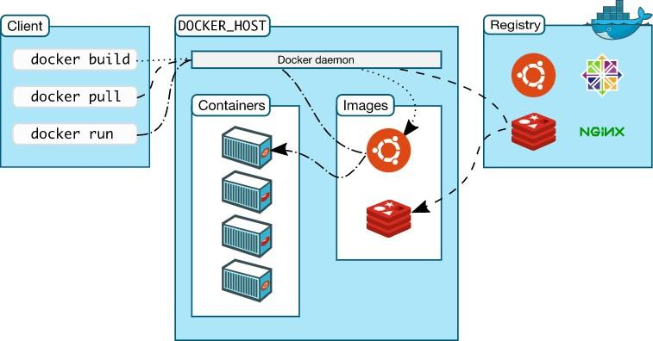

The Docker daemon

The Docker daemon (dockerd) listens for Docker API requests and manages Docker objects such as images, containers, networks, and volumes. A daemon can also communicate with other daemons to manage Docker services.

The Docker client

The Docker client (docker) is the primary way that many Docker users interact with Docker. When you use commands such as docker run, the client sends these commands
to dockerd, which carries them out. The docker command uses the Docker API. The Docker client can communicate with more than one daemon.

Docker Desktop

Docker Desktop is an easy-to-install application for your Mac or Windows environment that enables you to build and share containerized applications and microservices. Docker Desktop includes the Docker daemon (dockerd), the Docker client (docker), Docker Compose, Docker Content Trust, Kubernetes, and Credential Helper. For more information, see Docker Desktop.

Docker registries

A Docker registry stores Docker images. Docker Hub is a public registry that anyone can use, and Docker is configured to look for images on Docker Hub by default. You can even run your own private registry.
When you use the docker pull or docker run commands, the required images are pulled from your configured registry. When you use the docker push command, your image is pushed to your configured registry.

Docker objects

When you use Docker, you are creating and using images, containers, networks, volumes, plugins, and other objects. This section is a brief overview of some of those objects.

Images

An image is a read-only template with instructions for creating a Docker container.
Often, an image is based on another image, with some additional customization. For example, you may build an image which is based on the ubuntu image, but installs the Apache web server and your application, as well as the configuration details needed to make your application run.
You might create your own images or you might only use those created by others and published in a registry. To build your own image, you create a Dockerfile with a simple syntax for defining the steps needed to create the image and run it. Each instruction in a Dockerfile creates a layer in the image. When you change the Dockerfile and rebuild the

image, only those layers which have changed are rebuilt. This is part of what makes images so lightweight, small, and fast, when compared to other virtualization technologies.

Containers

A container is a runnable instance of an image. You can create, start, stop, move, or delete a container using the Docker API or CLI. You can connect a container to one or more networks, attach storage to it, or even create a new image based on its current state.
By default, a container is relatively well isolated from other containers and its host machine. You can control how isolated a container’s network, storage, or other underlying subsystems are from other containers or from the host machine.
A container is defined by its image as well as any configuration options you provide to it when you create or start it. When a container is removed, any changes to its state that are not stored in persistent storage disappear.

8. Introduction to Prometheus

Prometheus is an open-source systems monitoring and alerting toolkit originally developed by SoundCloud. It has become a widely adopted solution for monitoring the performance and health of computer systems and applications in various environments. Here's a brief introduction to Prometheus:

Purpose: Prometheus is designed for monitoring and observability. It collects and stores metrics (time-series data) about the state and performance of systems and applications. This data helps operators and developers understand how their systems are behaving and identify issues or anomalies.

Data Model: Prometheus uses a unique data model based on time-series data. It collects and stores numerical data points over time, associating them with specific labels and metadata. This time-series data allows for powerful querying and visualization.

Data Collection: Prometheus employs a "pull" model for data collection, where it scrapes metrics from instrumented targets at regular intervals. Targets can be servers, containers, or any system emitting metrics in Prometheus's supported formats, such as the Prometheus exposition format or OpenMetrics.

Data Storage: Prometheus stores the collected time-series data in its own efficient and compressed format. This local storage is optimized for fast querying and allows for historical analysis of metrics.

Query Language: Prometheus comes with a powerful query language called PromQL, which allows users to perform complex queries and aggregations on the collected data. This is essential for creating custom alerts and dashboards.

Alerting: Prometheus includes an alerting system that can trigger notifications based on user-defined alert rules. When specific conditions are met in the data, alerts are generated and sent to alerting channels like email, Slack, or other integrations.

Visualization: While Prometheus itself focuses on data collection and storage, it integrates well with visualization tools like Grafana. Grafana can be used to create interactive dashboards and visual representations of the collected metrics.

Scalability: Prometheus is designed to be horizontally scalable, allowing users to set up federated or remote Prometheus servers to collect and aggregate metrics from multiple locations. This makes it suitable for monitoring complex and distributed environments.

Ecosystem: Prometheus has a rich ecosystem of exporters and integrations, which makes it versatile for monitoring a wide range of systems and services. It supports instrumenting popular software, databases, cloud services, and more.

Open Source: Prometheus is open-source software released under the Apache License 2.0. This open nature has led to a thriving community of contributors and extensive documentation.

In summary, Prometheus is a powerful, open-source monitoring and alerting system known for its scalability, flexible data model, and rich ecosystem of integrations. It has gained popularity in the DevOps and cloud-native communities for providing insight into the performance and health of systems and applications.

10. Implementation of Project
Creating Instance on AWS using Terraform
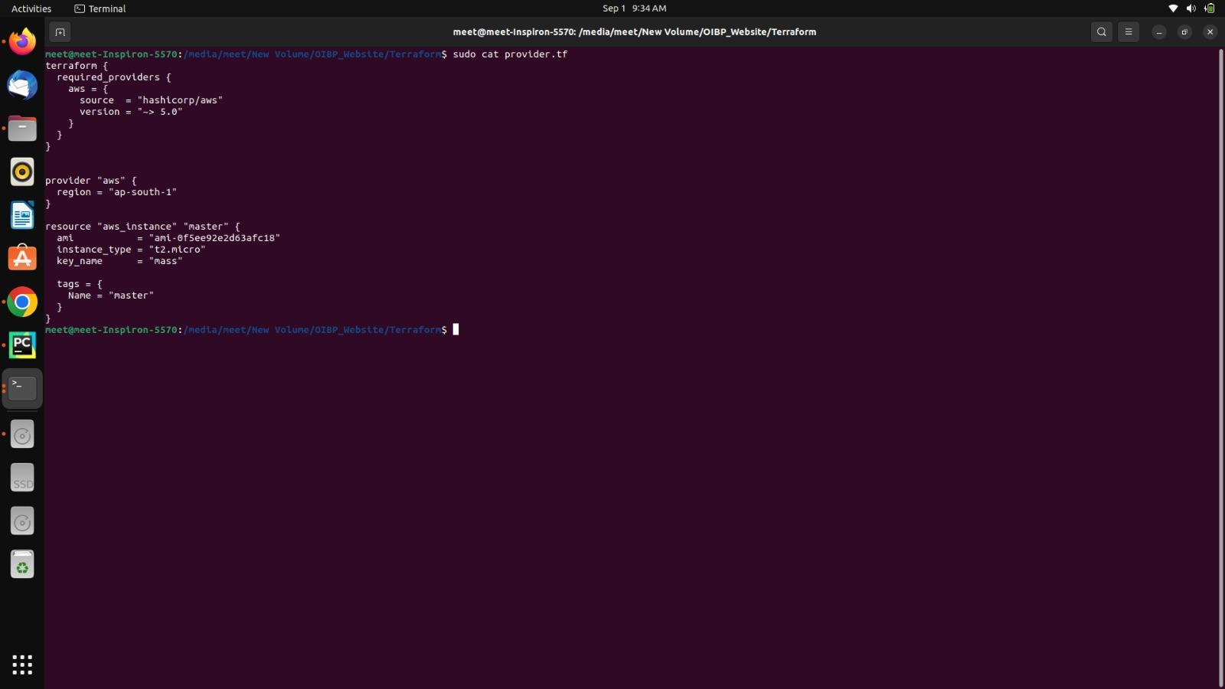
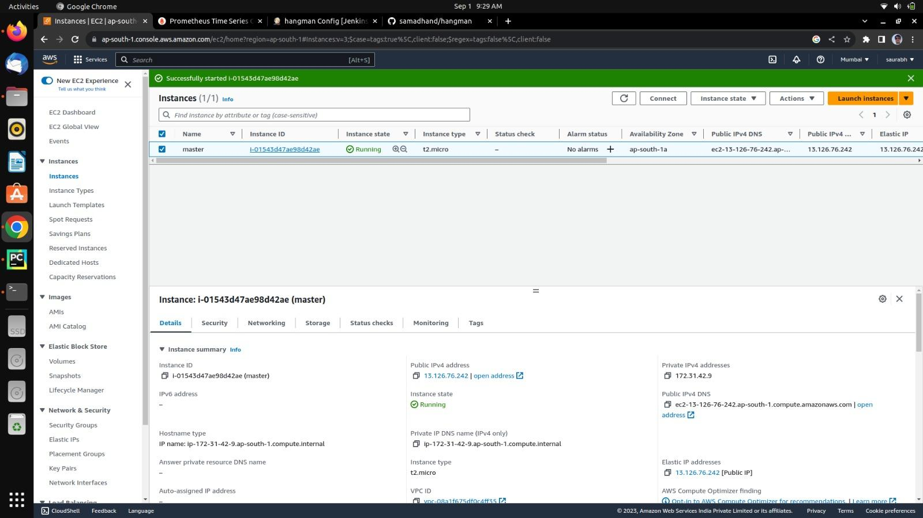

Source Code Management using Github for Web Application
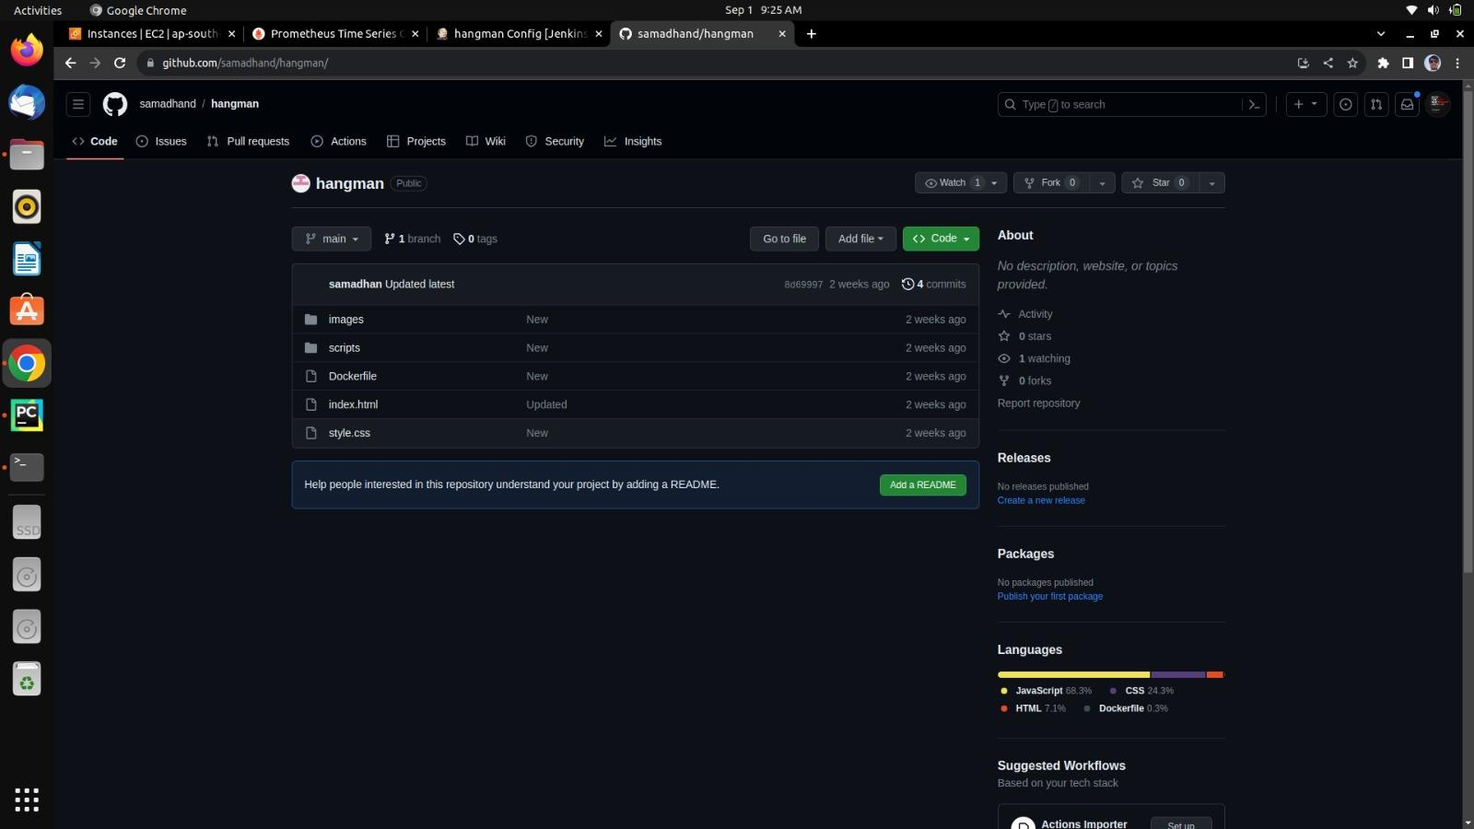

After Creating AWS instance, Logging in to the EC2instance through terminal
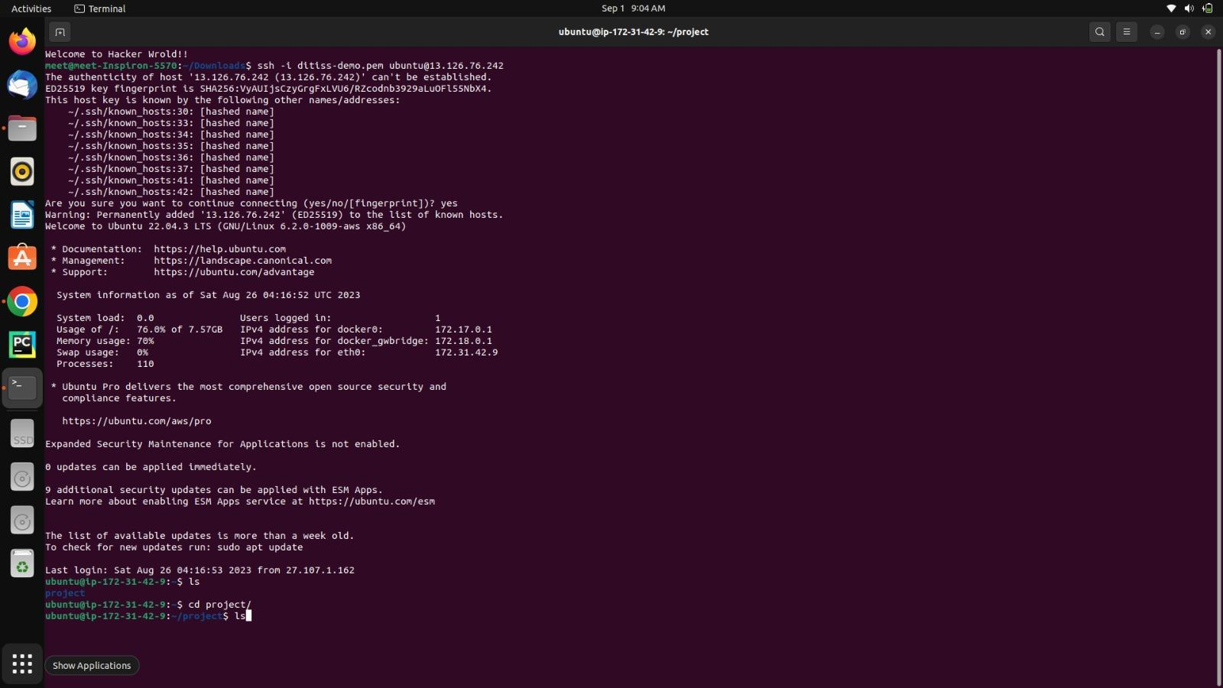

Configuring Web Application in the instances

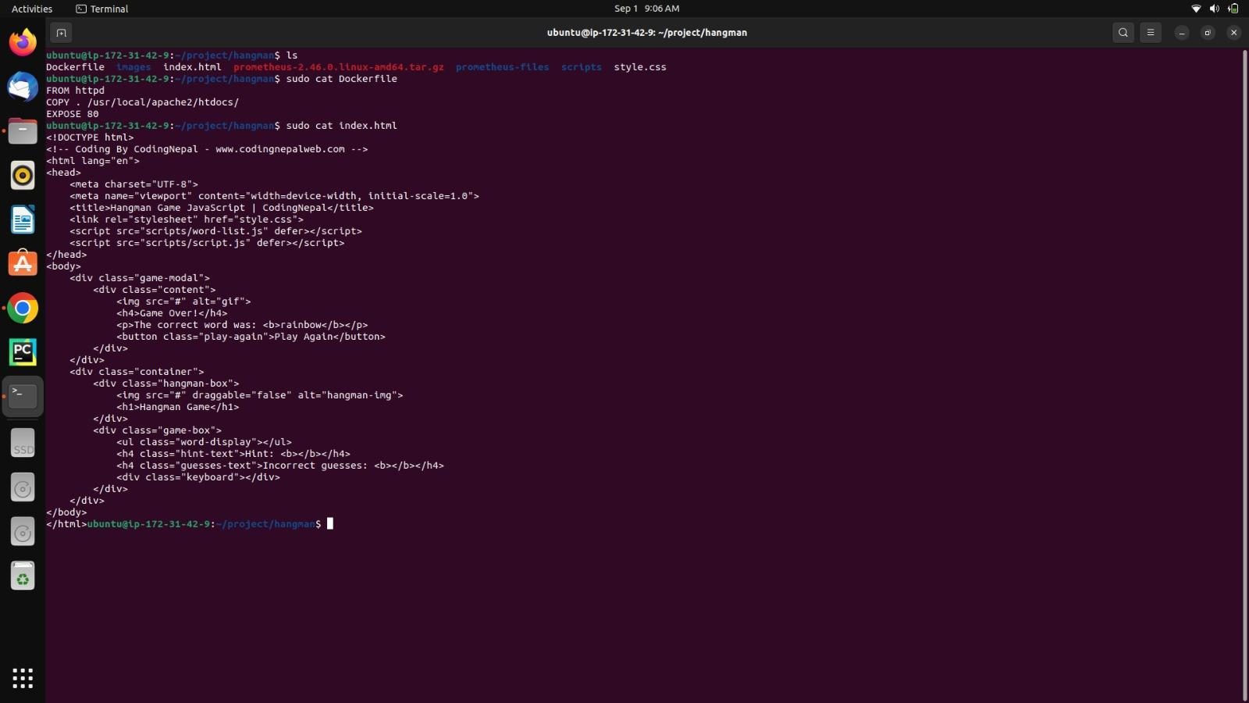

Snort Configuration and setting Snort Rules
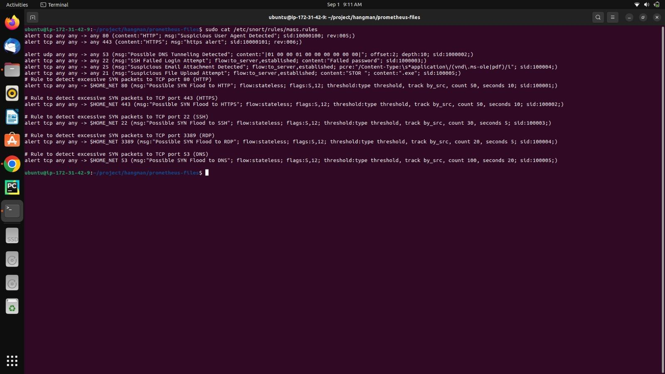

Configuring Prometheus and Setting Rules for monitoring

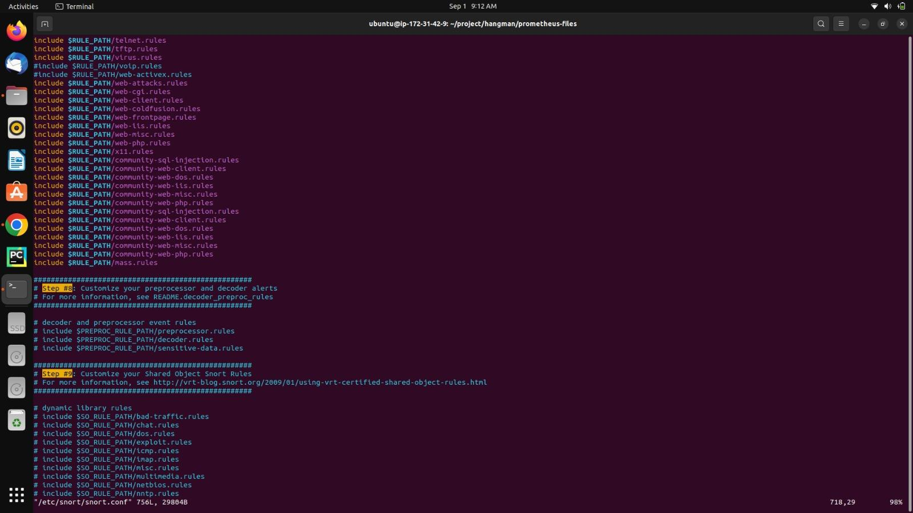

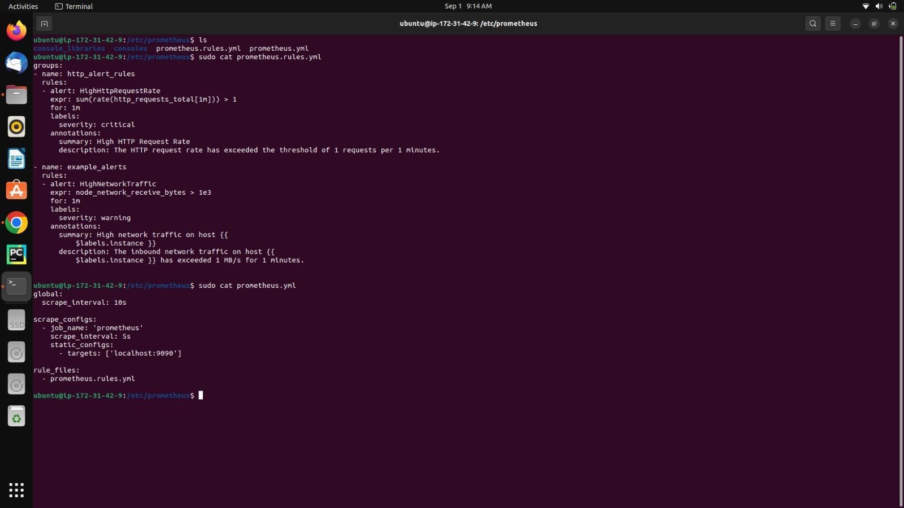

Prometheus Dashboard
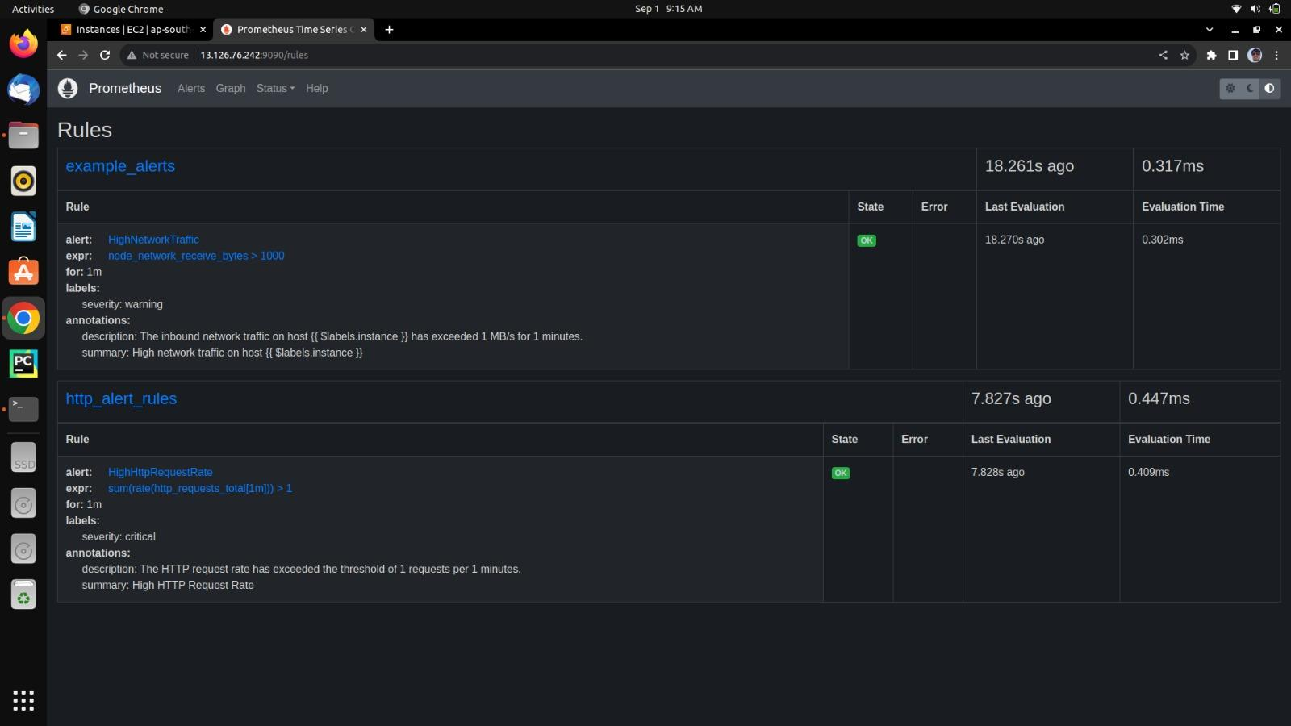

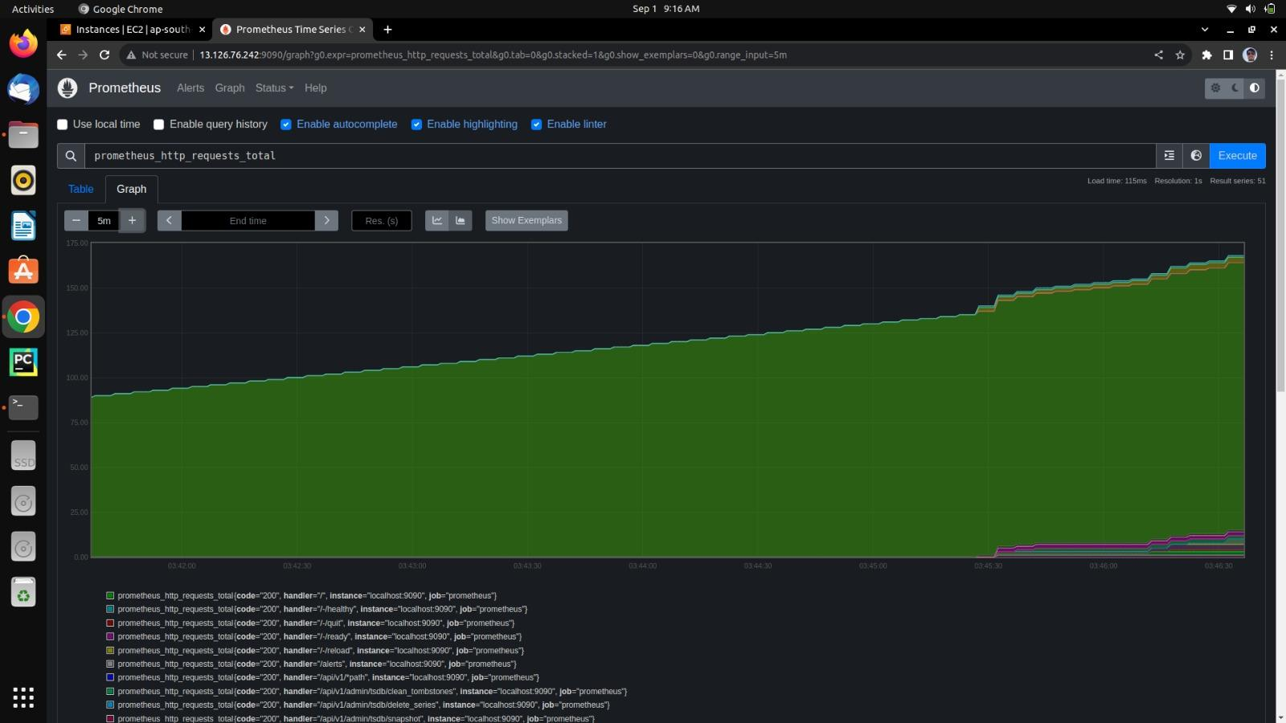

Creating docker image , service and deploying using Jenkins
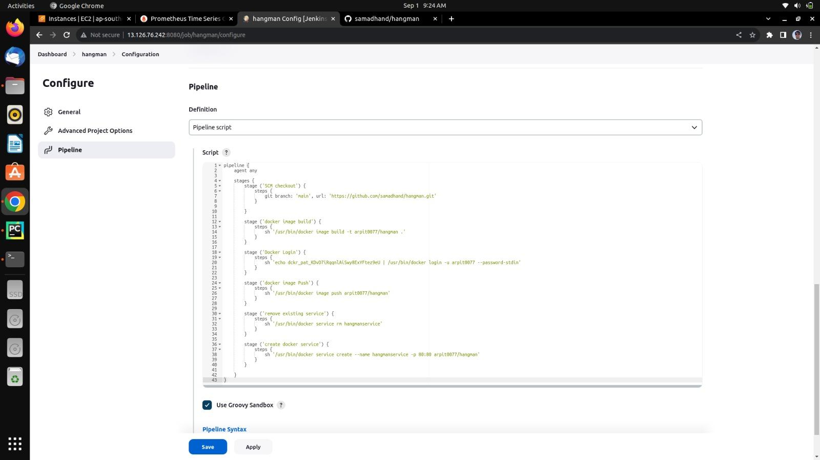

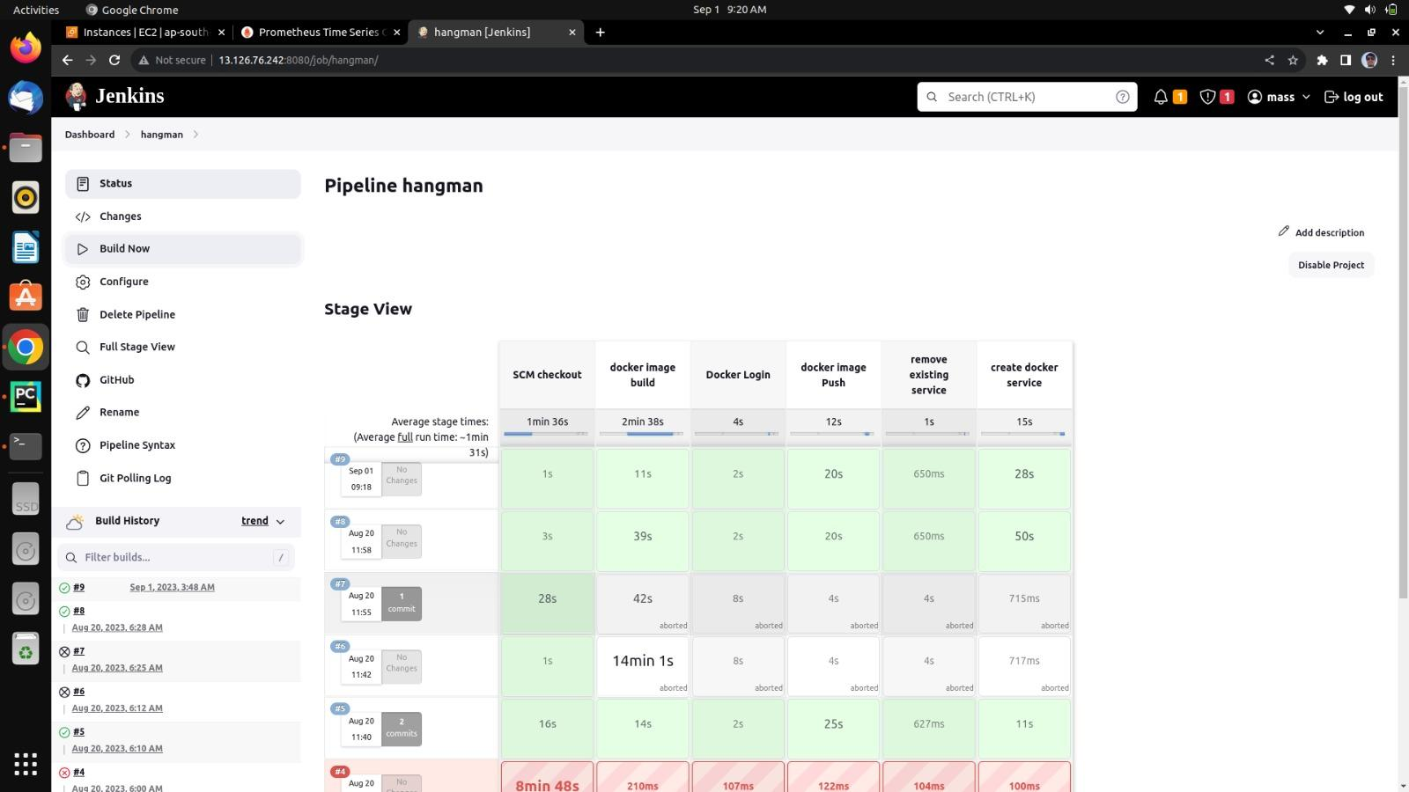

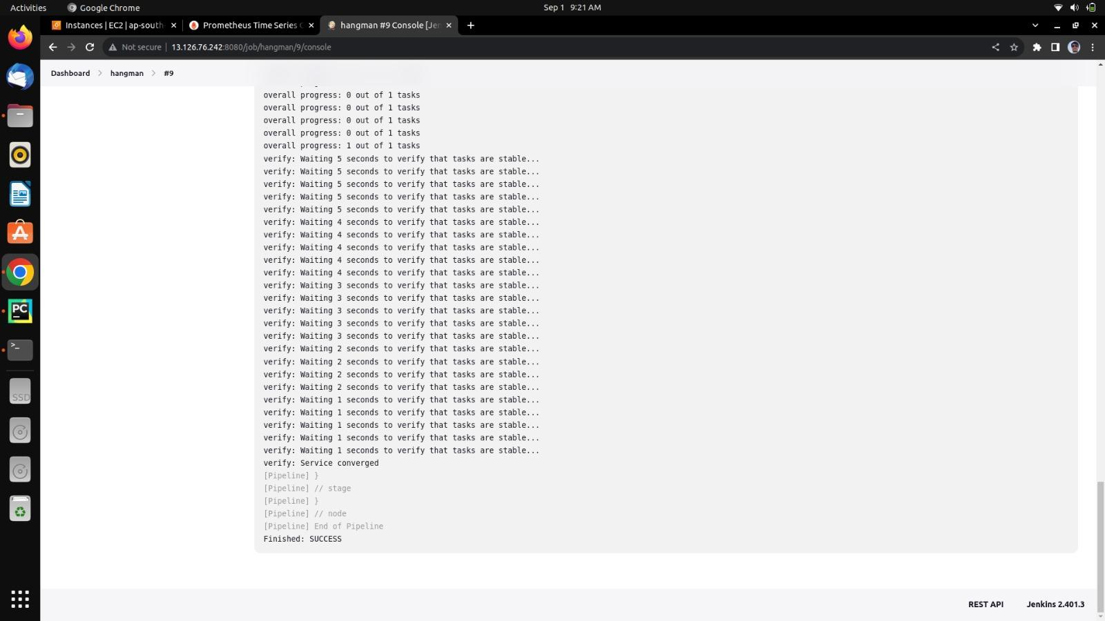
Deployment completed Successfully

Web Application Deployed Securely and Running on Docker Conatiner

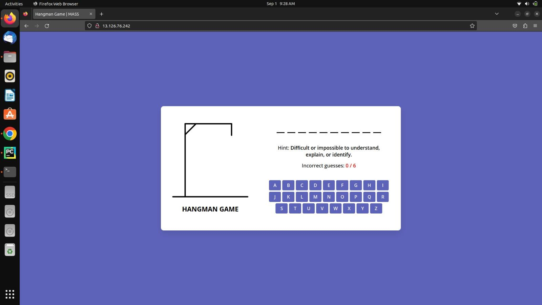

11. Future Scope

DevOps has been a buzzword for a few years now. We simply can’t imagine Future without proper implementation of the DevOps model. Security objectives should be integrated into the software development lifecycle from an early stage, which involves more than just building pipelines. It’s important for people to have the right mindset, understand the shared responsibility model and establish processes that support the methodology and continuous improvement. Organizations must focus on what technology they should be using going forward, and ensure that they are up to date with what the market has to offer.
Further we can implement dynamic code analysis, patch vulnerabilities found in Docker images scan and deploy containerized web application on any cloud platform.

12. Conclusion

DevOps empowers an organization to take a proactive approach to automation. It encourages software developers to integrate automation into their day-to-day efforts. At the same time, operations teams can work with software developers to help an organization identify and resolve any vulnerabilities before they get out of hand.
Expect the demand for DevOps to increase in organizations of all sizes and across all industries. As more organizations search for ways to automate deployment early in the software development process, the demand for tools to support DevOps will increase accordingly.
An organization that implements DevOps tools today could reap the benefits of that investment for a lifetime. By providing software developers and operations teams with user-friendly and effective DevOps tools, an organization fosters a culture of collaboration, communication, transparency and openness. As a result, this organization creates an environment where developers and operations teams drive ongoing improvement.

13. Flow Chart

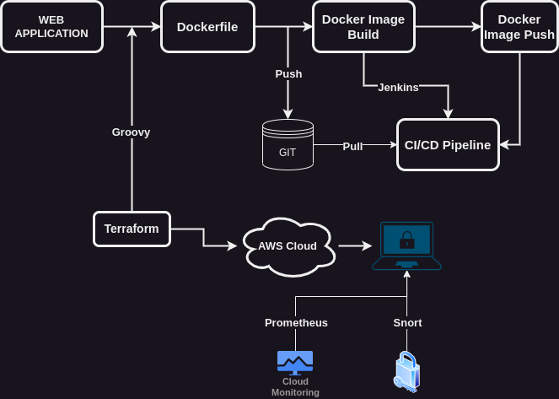

14. References.

https://docs.docker.com/get-started/overview/

https://www.google.com/search?q=jenkins+official+documentation&oq=jenkins+official+&aqs=chrome.0.0i512l2j69i57j0i512l2j0i22i30l5.8424j0j7&sourceid=chrome&ie=UTF-8

https://github.com/samadhand/hangman/

https://www.google.com/search?q=aws+official+documentation&oq=aws+official+documen&aqs=chrome.0.0i512j69i57j0i390i650.5142j0j9&sourceid=chrome&ie=UTF-8

https://www.google.com/search?q=prometheus+official+documentation&oq=prometheus+official+documen&aqs=chrome.0.0i512j69i57j0i390i650l4.11387j0j9&sourceid=chrome&ie=UTF-8

https://www.snort.org/documents

https://www.jenkins.io/doc/

https://developer.hashicorp.com/terraform/docs

